**Sri ASNM GOVT. COLLEGE (A), PALAKOL**

**FOREST DAY – MARCH 21-2022**

The **International Day of Forests** was established on the 21st day of March, by resolution of the [United Nations General Assembly](https://en.wikipedia.org/wiki/United_Nations_General_Assembly) on November 28, 2013. Each year, various events [celebrate](https://en.wikipedia.org/wiki/List_of_minor_secular_observances#March) and [raise awareness](https://en.wikipedia.org/wiki/Raising_awareness) of the importance of all types of forests, and trees outside forests, for the benefit of current and future generations. Countries are encouraged to undertake efforts to organize local, national, and international activities involving forests and trees, such as tree planting campaigns, on International Day of Forests. The Secretariat of the [United Nations Forum on Forests](https://en.wikipedia.org/wiki/United_Nations_Forum_on_Forests), in collaboration with the [Food and Agriculture Organization](https://en.wikipedia.org/wiki/Food_and_Agriculture_Organization), facilitates the implementation of such events in collaboration with governments, the [Collaborative Partnership on Forests](https://en.wikipedia.org/wiki/Collaborative_Partnership_on_Forests), and international, regional and sub-regional organizations. International Day of Forests was observed for the first time on March 21, 2013.

**Theme:- “Forests and Sustainable Production and Consumption**”

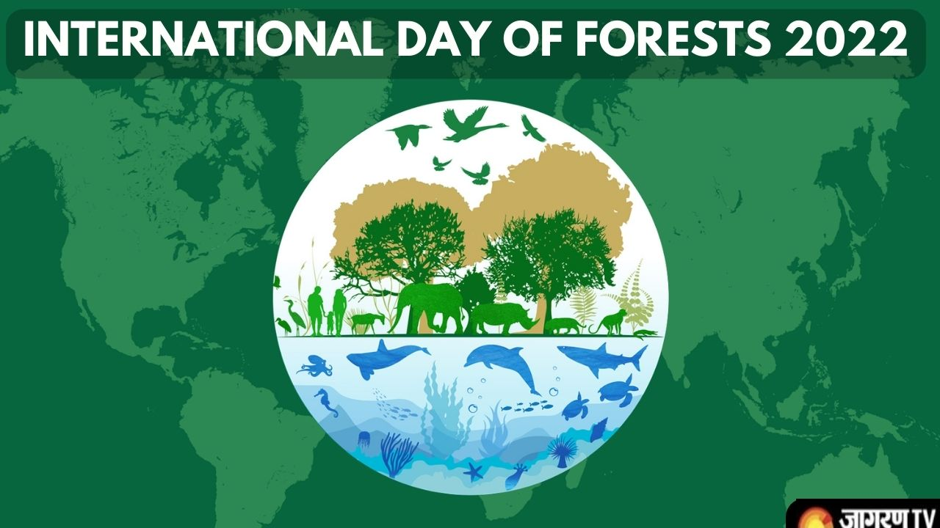

Lecturers Sign Principal sign

**21-03-2022**

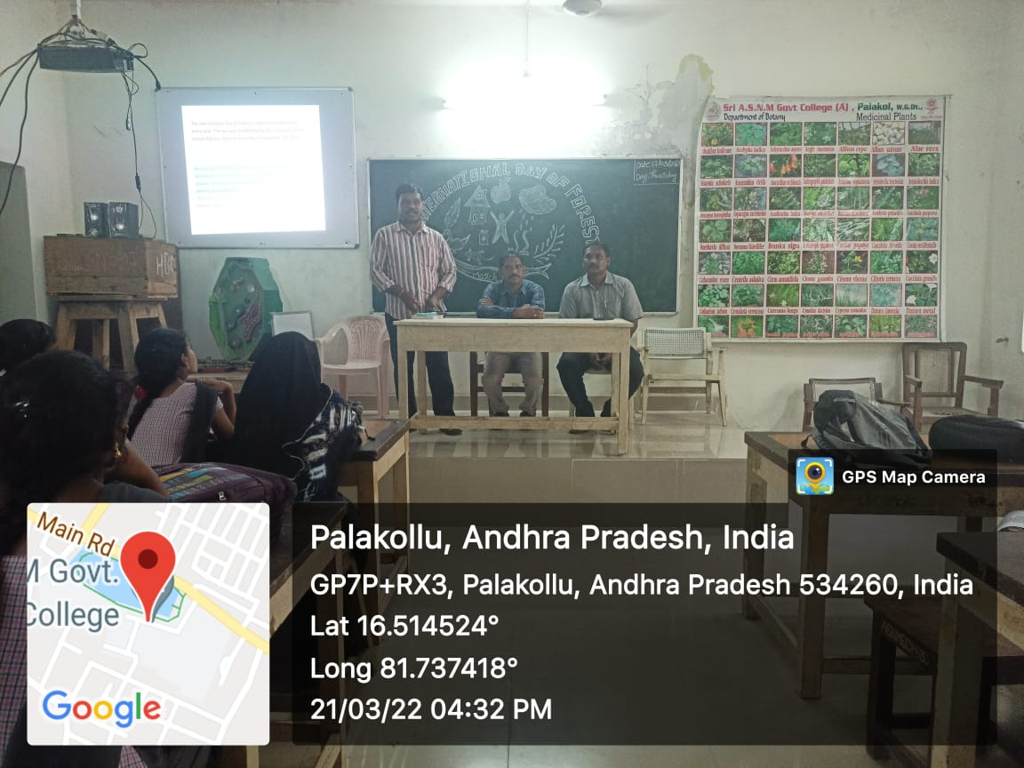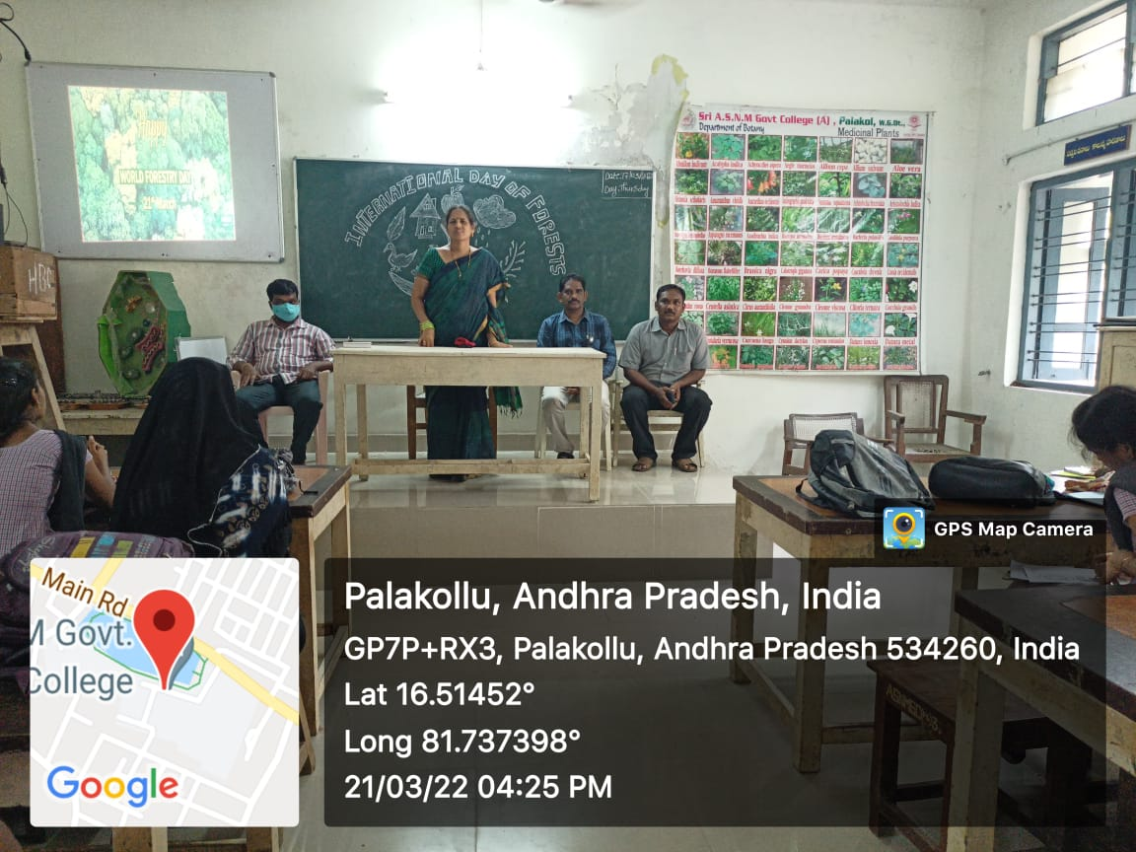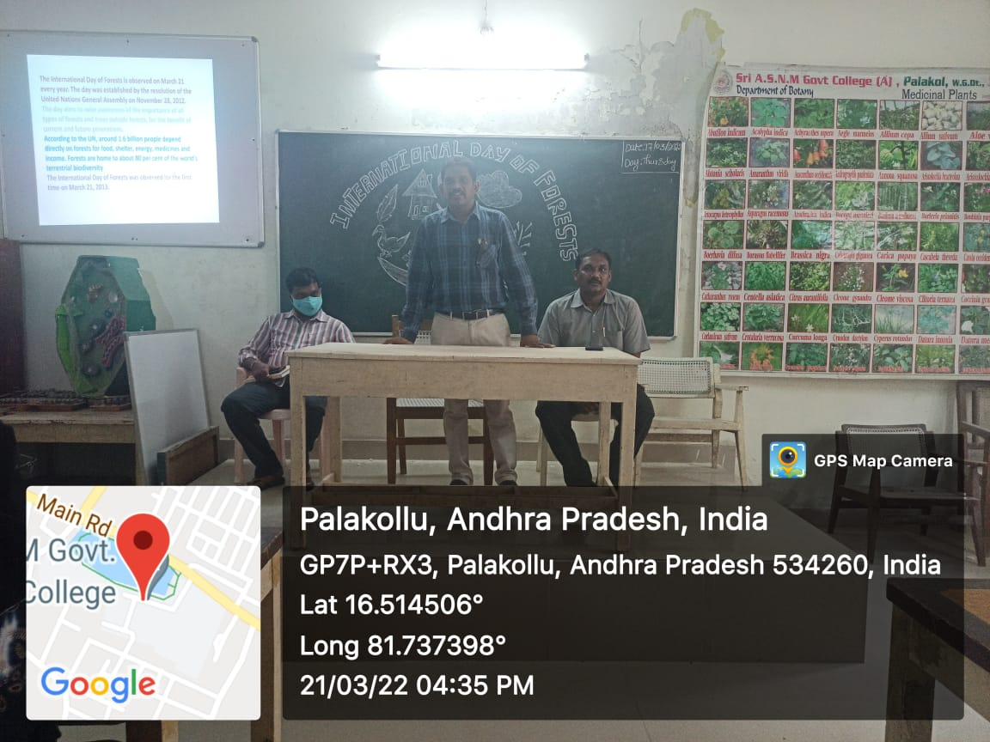

On 21-03-2022 Sri ASNM Government (A) College, Palakol Celebrated the International Forest Day which was Organized by Department of Botany and conducted a programme and students were actively participated and in this programme Our Respected College Principal Dr. T Rajarajeswari explained about the important role of forest in the environmental stability. After that Dr. M Ramakrishna HOD of Zoology Explained about the importance of forests in Biodiversity. Sri G Srinivasa Rao HOD of Physics shared his ideas to conserve the forest. Finally Dr. Y Vijaya kumar explained about the adverse effects of Deforestation to the climate.